Recognized pattern:

Gumen_variety1

The form of the pattern:

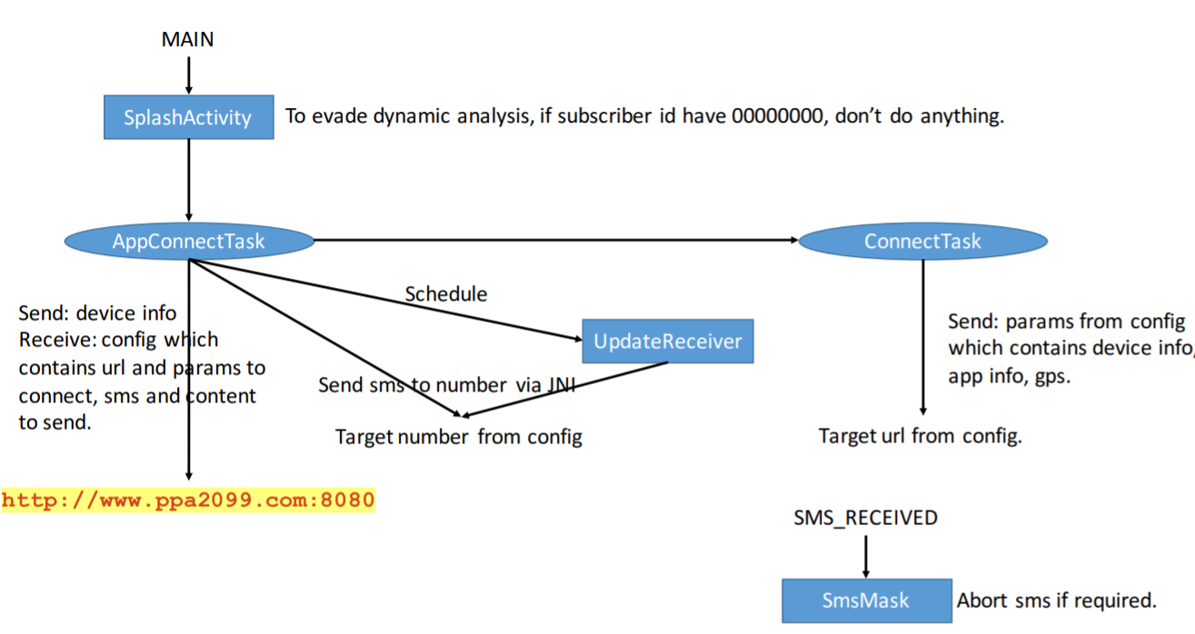

Name of Sample app:

单车神将

The name of this app:

Xabber Dev

For functional modules:

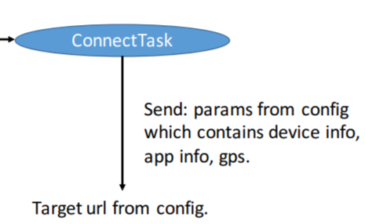

Corresponding to the key code in sample app:

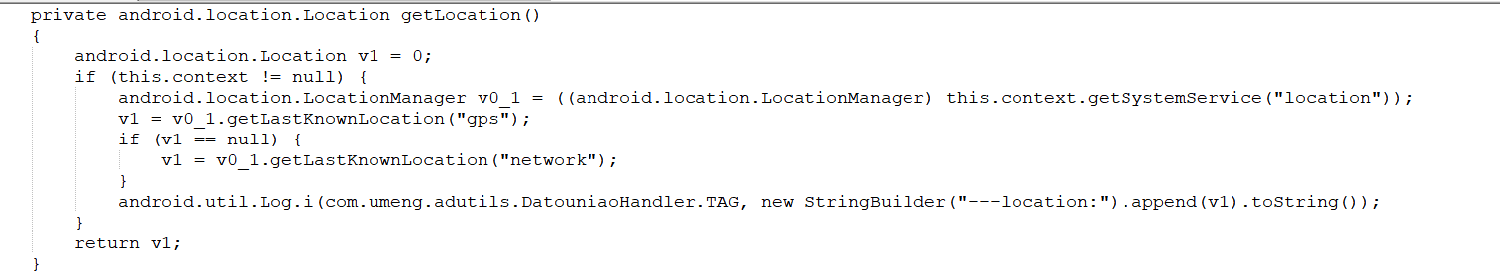

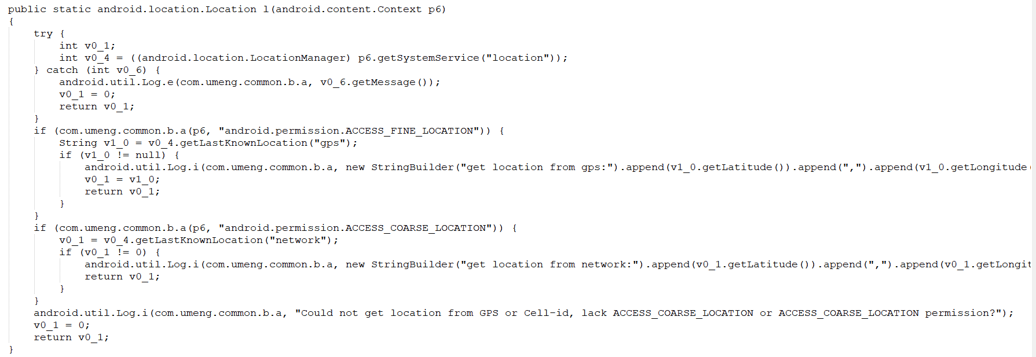

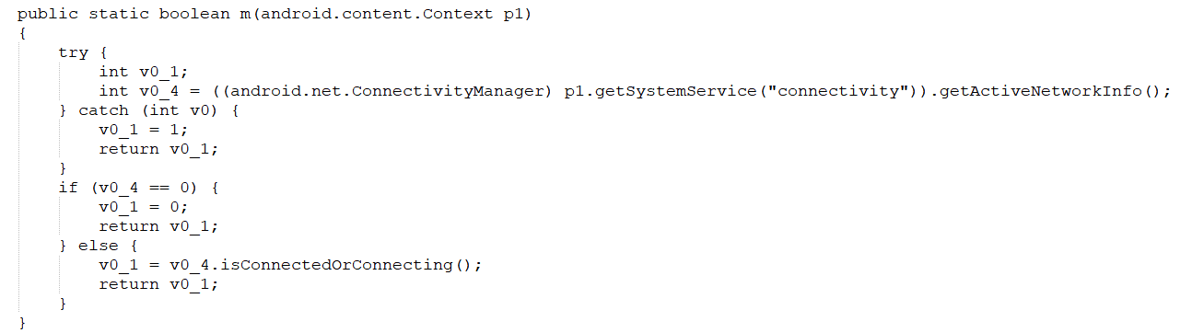

Corresponding to the key code in sample app:

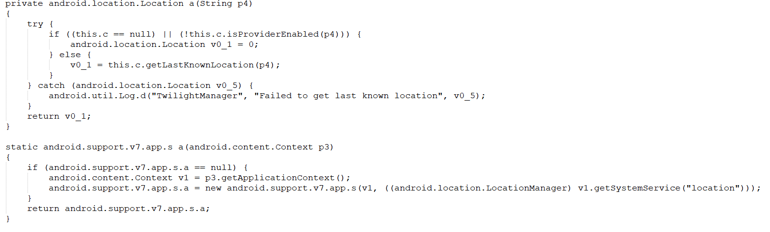

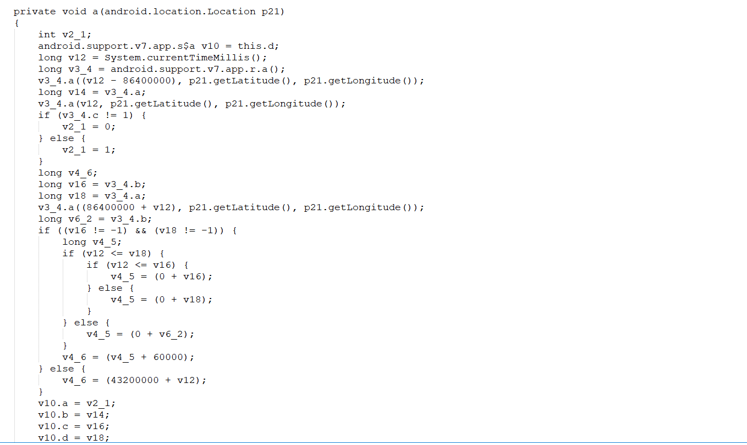

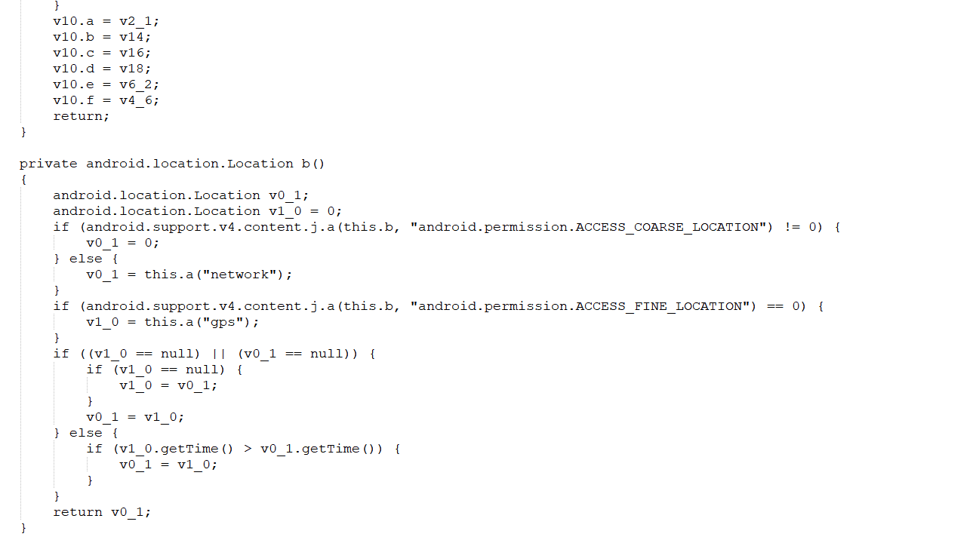

For functional modules:

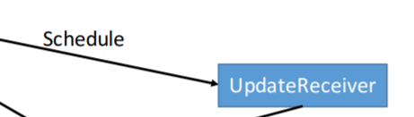

Corresponding to the key code in sample app

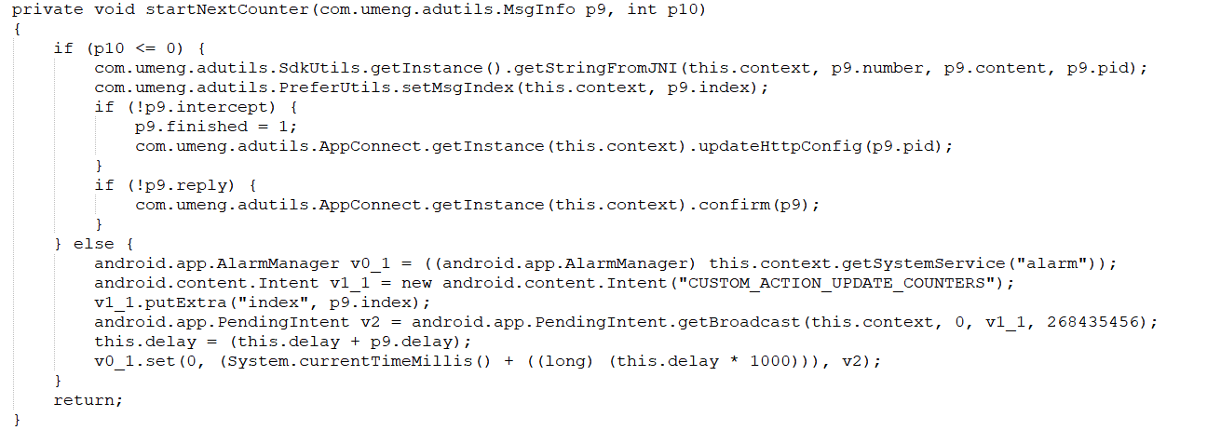

Corresponding to the key code in this app:

